

**A Mini -Project Report On**

**“Heart Disease Prediction"**

**Machine Learning**

**Submitted by**

**P.Satish(19B21A0440)**

**R.Raja Rajeswari(19JN1A0515)**

**R.Keerthi(19JN1A0570)**

**G.Durga Bhavani(19JN1A0546)**

**D.Dharani(19JN1A0523)**

**Submitted to**

**Dr.Krish Naik**

**Chief Innovation Officer**

**Submission Date: December-19,2021**

**INDEX**

**1.Introduction**

**2.Dimensionality Reduction**

**3.Algorithms and Techniques used **

a. Naive b ayes

b. Support vector machine

c.Decision tree

1.Introduction

Heart is an important organ of the human body. It pumps blood to every part of our anatomy. If it fails to function correctly, then the brain and various other organs will stop working, and within few minutes, the person will die. Change in lifestyle, work related stress and bad food habits contribute to the increase in rate of several heart related diseases. Heart diseases have emerged as one of the most prominent cause of death all around the world. According to World Health Organisation, heart related diseases are responsible for the taking 17.7 million lives every year, 31% of all global deaths. In India too, heart related diseases have become the leading cause of mortality [1]. Heart diseases have killed 1.7 million Indians in 2016, according to the 2016 Global Burden of Disease Report, released on September 15,2017. Heart related diseases increase the spending on health care and also reduce the productivity of an individual. Estimates made by the World Health Organisation (WHO), suggest that India have lost up to $237 billion, from 2005-2015, due to heart related or Cardiovascular diseases [2]. Thus, feasible and accurate prediction of heart



related diseases is very important. Medical organisations, all around the world, collect data on various health related issues. These data can be exploited using various machine learning techniques to gain useful insights. But the data collected is very massive and, many a times, this data can be very noisy. These datasets, which are too overwhelming for human minds to comprehend, can be easily explored using various machine learning techniques. Thus, these algorithms have become very useful, in recent times, to predict the presence or absence of heart related diseases accurately.

2.Dimensionality Reduction

Dimensionality Reduction involves selecting a mathematical representation such that one can relate the majority of, but not all, the variance within the given data, thereby including only most significant information. The data considered for a task or a problem, may consists of a lot of attributes or dimensions, but not all of these attributes may equally influence the output. A large number of attributes, or features, may affect the computational complexity and may even lead to overfitting which leads to poor results. Thus, Dimensionality Reduction is a very important step considered while building any model. Dimensionality Reduction is generally achieved by two methods -Feature Extraction and Feature Selection.

3.Algorithms and Techniques used

A. Naïve Bayes

Naive Bayes is a simple but an effective classification technique which is based on the Bayes Theorem. It assumes independence among predictors, i.e., the attributes or features should be not correlated to one another or should not, in anyway, be related to each other. Even if there is dependency, still all these features or attributes independently contribute to the probability and that is why it is called Naïve. In [7], Naive Bayes has achieved an accuracy of 84.1584% with the 10 most significant features which are selected using SVMRFE (Recursive Feature Elimination) and gain ratio algorithms whereas in[8],Naive Bayes has achieved an accuracy of 83.49% when all 13 attributes of the Cleveland dataset[25] are used.

B. Support Vector Machine

Support Vector Machine is an extremely popular supervised machine learning technique(having a pre-defined target variable) which can be used as a classifier as well as a predictor. For classification, it finds a hyper-plane in the feature space that differentiates between the classes. An SVM model represents the training data points as points in the feature space, mapped in such a way that points belonging to separate classes are segregated by a margin as wide as possible. The test data points are then mapped into that same space and are classified based on which side of the margin they fall.

C. Decision Tree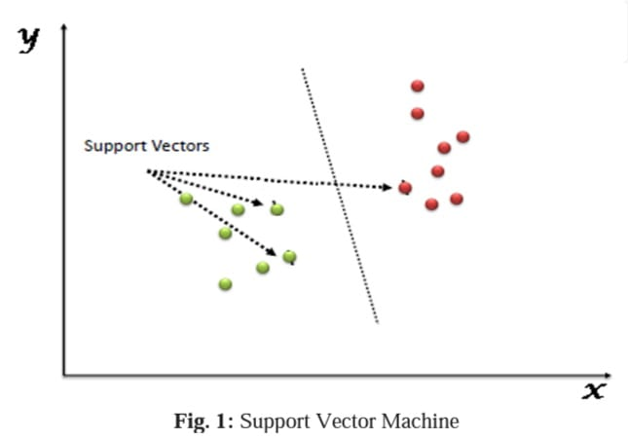

Decision tree is a of supervised learning algorithm.This technique is mostly used in classification problems. It performs effortlessly withcontinuous and categorical attributes. This algorithm dividesthe population into two or more similar sets based on the most significantpredictors.Decision Treealgorithm, first calculates the entropy of each and every attribute. Then the dataset is split with the help of thevariables or predictors with maximum information gain or minimum entropy. These two steps are performed recursively with the remaining attributes

Entropy(S) = sigma(sum of )-p log2 pi

Gain(S,A) = entropy – sum of |Sv|/|S| entropy(Sv)

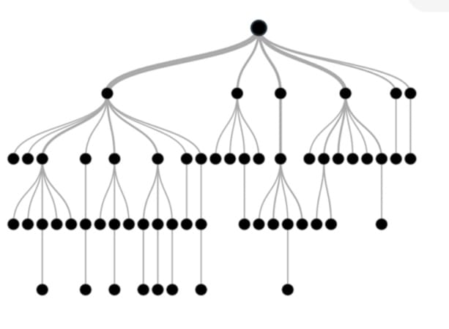

D. Ensemble Model

In ensemble modeling two or more related but different analytical models are used and produce their results are combined into a single score. TahiraMahboob et al. [22] have used an ensemble of SVM, KNN and ANN to achieve an accuracy of 94.12%. The Majority votebased model as demonstrated by Saba Bashir et al. [23] which comprises of Naïve Bayes, Decision Tree and Support Vector Machine classifiers, gave an accuracy of 82%, sensitivity of 74% and specificity of 93% for UCI heart disease dataset. In [24] an ensemble model, consisting ofGini Index,SVMand Naïve Bayes classifiers, has been proposed which gave an accuracy of 98% in predicting Syncope disease.

4. Conclusion

Based on the above review, it can be concluded that there is a huge scope for machine learning algorithms in predicting cardiovascular diseases or heart related diseases. Each of the above-mentioned algorithms have performed extremely well in some cases but poorly in some other cases. Alternating decision trees when used with PCA, have performed extremely well but decision trees have performed very poorly in some other cases which could be due to overfitting. Random Forest and Ensemble models have performed very well because they solve the problem of overfitting by employing multiple algorithms (multiple Decision Trees in case of Random Forest). Models based on Naïve Bayes classifier were computationally very fast and have also performed well.SVM performed extremely well for most of the cases. Systems based on machine learning algorithms and techniques have been very accurate in predicting the heart related diseases but still there is a lot scope of research to be done on how to handle high dimensional data and overfitting. A lot of research can also be done on the correct ensemble of algorithms to use for a particular type of data. 5. Acknowledgment We sincerely thank the staff of SRM Institute of Science and Technology, that have provided their immense support and guidance throughout the project

Reference

[1] Ramadoss and Shah B et al.“A. Responding to the threat of chronic diseases in India”. Lancet. 2005; 366:1744–1749. doi: 10.1016/S0140-6736(05)67343-6.

[2] Global Atlas on Cardiovascular Disease Prevention and Control. Geneva, Switzerland: World Health Organization, 2011

[3] Dhomse Kanchan B and Mahale Kishor M. et al. “Study of Machine Learning Algorithms for Special Disease Prediction using Principal of Component Analysis”, 2016 International Conference on Global Trends in Signal Processing, Information Computing and Communication.

[4] R.Kavitha and E.Kannan et al. “An Efficient Framework for Heart Disease Classification using Feature Extraction and Feature Selection Technique in Data Mining “, 2016

[5] Shan Xu ,Tiangang Zhu, Zhen Zang, Daoxian Wang, Junfeng Hu and Xiaohui Duan et al. “Cardiovascular Risk Prediction Method Based on CFS Subset Evaluation and Random Forest Classification Framework”, 2017 IEEE 2nd International Conference on Big Data Analysis.

[6] Manpreet Singh, Levi Monteiro Martins, Patrick Joanis and Vijay K. Mago et al. “ Building a Cardiovascular Disease Predictive Model using Structural Equation Model & Fuzzy Cognitive Map”, 978-1-5090-0626-7/16/$31.00 c 2016 IEEE.

[7] Kanika Pahwa and Ravinder Kumar et al. “Prediction of Heart Disease Using Hybrid Technique For Selecting Features”, 2017 4th IEEE Uttar Pradesh Section International Conference on Electrical, Computer and Electronics (UPCON).

[8] Seyedamin Pouriyeh, Sara Vahid, Giovanna Sannino, Giuseppe De Pietro, Hamid Arabnia, Juan Gutierrez et al. “ A Comprehensive Investigation and Comparison of Machine Learning Techniques in the Domain of Heart Disease”, 22nd IEEE Symposium on Computers and Communication (ISCC 2017): Workshops - ICTS4eHealth 2017

[9] Hanen Bouali and Jalel Akaichi et al. “Comparative study of Different classification techniques, heart Diseases use Case.”, 2014 13th International Conference on Machine Learning and Applications

[10] Seyedamin Pouriyeh, Sara Vahid, Giovanna Sannino, Giuseppe De Pietro, Hamid Arabnia, Juan Gutierrez et al. “ A Comprehensive Investigation and Comparison of Machine Learning Techniques in the Domain of Heart Disease”, 22nd IEEE Symposium on Computers and Communication (ISCC 2017): Workshops - ICTS4eHealth 2017

[11] Houda Mezrigui, Foued Theljani and Kaouther Laabidi et al. “Decision Support System for Medical Diagnosis Using a KernelBased Approach”, ICCAD’17, Hammamet - Tunisia, January 19- 21, 2017.

[12] Dr.(Mrs).D.Pugazhenthi, Quaid-E-Millath and Meenakshi et al. “Detection Of Ischemic Heart Diseases From Medical Images “ 2016 International Conference on Micro-Electronics and Telecommunication Engineering.

[13] J. Hodges et al. “Discriminatory analysis, nonparametric discrimination: Consistency properties,” 1981.

[14] S.Rajathi and Dr.G.Radhamani et al. “Prediction and Analysis of Rheumatic Heart Disease using kNN Classification with ACO “, 2016.

[15] Puneet Bansal and Ridhi Saini et al. “Classification of heart diseases from ECG signals using wavelet transform and kNN classifier”, International Conference on Computing, Communication and Automation (ICCCA2015).

[16] Simge EKIZ and Pakize Erdogmus et al. “Comparitive Study of heart Disease Classification”, 978-1-5386-0440-3/17/$31.00 ©2017 IEEE.

[17] Renu Chauhan, Pinki Bajaj, Kavita Choudhary and Yogita Gigras et al. “Framework to Predict Health Diseases Using Attribute International Journal of Engineering & Technology 687 Selection Mechanism”, 2015 2nd International Conference on Computing for Sustainable Global Development (INDIA Com).

[18] M.A.JABBAR , B.L Deekshatulu and Priti Chndra et al. “Alternating decision trees for early diagnosis of heart disease”, Proceedings of International Conference on Circuits, Communication, Control and Computing (I4C 2014).  
 [19] Amir Hussain, Peipei Yang, Mufti Mahmud and Jan Karasek et al. “A Novel Cardiovascular Decision Support Framework for effective clinical Risk Assessment.”, 978 - 1 -4799 -4527 - 6/14/$31.00 ©2014 IEEE.

[20] Quazi Abidur Rahman, Larisa G. Tereshchenko, Matthew Kongkatong, Theodore Abraham, M. Roselle Abraham, and Hagit Shatkay et al. “Utilizing ECG -based Heartbeat Classification for Hypertrophic Cardiomyopathy Identification”, DOI 10.1109/TNB.2015.2426213, IEEE Transactions on Nano Bioscience TNB -00035 -2015.

[21] Ahmad Shahin, Walid Moudani, Fadi Chakik, Mohamad Khalil et al. ”Data Mining in Healthcare Information Systems: Case Studies in Northern Lebanon”, ISBN: 978 - 1 -4799 -3166 -8 ©2014 IEEE.

[22] Tahira Mahboob, Rida Irfan and Bazelah Ghaffar et al. “Evaluating Ensemble Prediction of Coronary Heart Disease using Receiver Operating Characteristics”, 978 - 1 -5090 -4815 - 1/17/$31.00 ©2017 IEEE.

[23] Saba Bashir, Usman Qamar, M.Younus Javed et al. “An Ensemble based Decision Support Framework for Intelligent Heart Disease Diagnosis” International Conference on Information Society (i - Society 2014).

[24] Ammar Asjad Raja, Irfan -ul -Haq , Madiha Guftar Tamim Ahmed Khan and Dominik Greibl et al. “Intelligent Syncope Disease Prediction Framework using DM -Ensemble Techniques”, FTC 2016 - Future Technologies Conference 2016.

[25] CI Education, Heart Disease Data Set [OL]. http://archive.ics.uci.edu/ml/datasets/Heart+Disease CHDD.

[26] T. Padmapriya and V.Saminadan, “Handoff Decision for Multi - user Multiclass Traffic in MIMO -LTE -A Networks”, 2nd International Conference on Intelligent Computing, Communication & Convergence (ICCC -2016) – Elsevier - PROCEDIA OF COMPUTER SCIENCE, vol. 92, pp: 410 -417, August 2016.

[27] S.V.Manikanthan and D.Sugandhi “Interference Alignment Techniques For Mimo Multicell Based On Relay Interference Broadcast Channel” International Journal of Emerging Technology in Computer Science & Electronics (IJETCSE) ISSN: 0976 -1353 Volume - 7, Issue 1 –MARCH 2014

Thanking you sir